Spring boot security.

Spring boot with exception handling

In project we can create more than one rest controller. So if want to handle exception then in each controller method we need to write try – catch block with generic or specific exception

If we want to global exception for all method part of one controller then we can write separate method with @ExceptionHandler annotation. This method is responsible to handle all type of exception in that controller.

But we need to global exception handler class then we need to create separate class with @ControllerAdvice annotation and inside this we can write more than one method with annotation @ExceptionHandler to handle generic or specific exception.

**Creating new project with web starter and devtool**

Spring boot Actuator : it is a type of starter which provide set of end point which help to check your application health, matrix and some information.

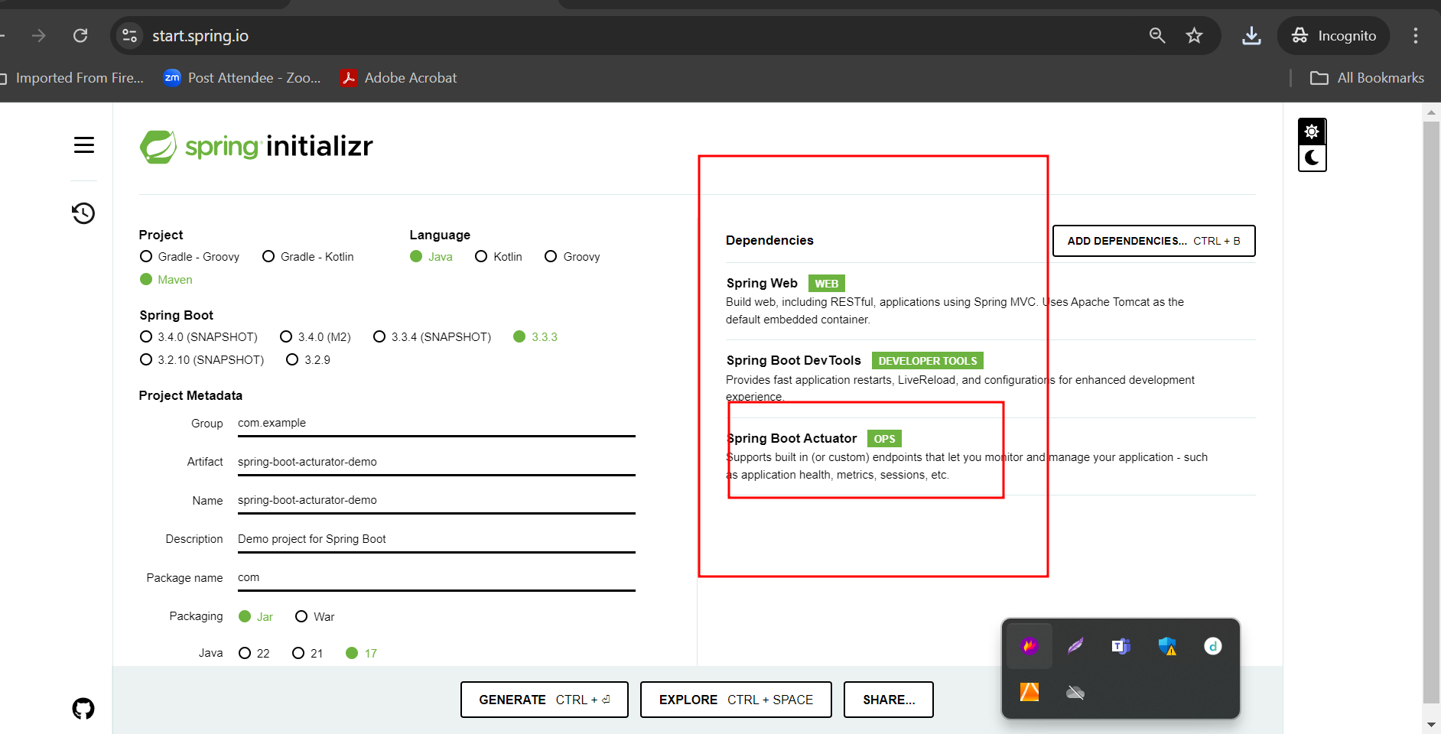

<http://localhost:8080/actuator/health>

